Encinal High School  Athletic Boosters – Board Meeting  Minutes  February 13, 2017 6:30pm | 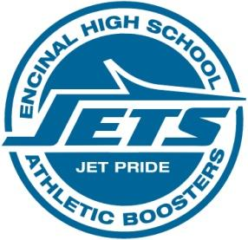

1) Motion Items
Motion 1 Approve Minutes from 01/12/17 Booster meeting
Initial Motion: Dave Skaff
Second: Kris Nelson
All in favor

2) Discussion Items
a. Athletic Packets are now available for online submission. Paper copies are still available for anyone that needs them.

3) Treasurer’s Report

4) Old Business
All old business was relevant to the crab feed

5) New Business
None

6) Crab Feed
- Diana Fong picked up flyers from the office for distribution
- PR person is supposed to posting Crab Feed info. in all social media outlets, news outlets, etc. Marie Long gave him the update of all places she’s posted so far and is bowing out.
- Food committee is headed up by Connie
- Start time for committee set up is 12pm
- Marie Long and Kevin Gorham (?) are picking up food from Little House at 12 noon
- New software training was done by Gladys to anyone interested in learning
- Ticket sales update - VIP tables are selling quickly but we need individual names of all people at the table.

