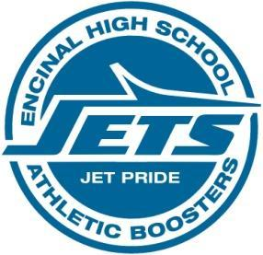
Encinal High School Athletic Boosters
Board & General Membership Meeting
June 11, 2018 6:30 PM
Pier 29 Restaurant, Alameda

Agenda -draft
1) Welcome and Introductions
2) Treasurer’s Report –Vincent San Nicolas
3) Athletic Director’s Report - Kevin Gorham

4) Old Business
a) May 14 meeting minutes & May 16 Special meeting minutes – VOTE ITEM
b) Revised bylaws, description of additional vice presidents, term limits, – VOTE ITEM
c) Snack Shack and Shed Contract Approval– VOTE ITEM
c) Banner Sponsorship Revised documents for website –review, possibly VOTE ITEM
d) Booster board nominations deadline extended. No volunteers as of 6/9/2018
6) New Business and Discussion Items
a) President Skaff presents a year end report on Boosters, membership and budget for 2018-19
b) Discussion of funding a donation account for Athletic Directors
c) Booster Meetings will be held at Pier 29 at 6:30pm for 2018-19. Need to set meeting dates .

