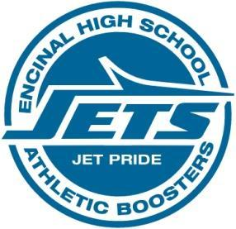
Encinal High School Athletic Boosters
Board Meeting Minutes/ Spring Family Sports Night -OFFICIAL
February 12, 2018 6:30 pm EHS Cafeteria, Alameda
Attendees: David Skaff, Sam Featherstone, Sunny Merry, Kris Nelson, Helene Onaga, Lani Molina,
Vincent San Nicolas, Suzanne Vinson, Diana Fong, Kevin Gorham
1) Welcome
2) Treasurer’s Report-

  - Diana Fong passed out copies of Nov 2017, Dec 2017, Jan 2018 reports from Vincent San Nicolas to board members
  - Report will be reviewed at next board meeting due to Spring Family Sports Night event

- Athletic Director’s Presentation to Families: EHS sports participation rules, code of conduct, grades and eligibility.
- EHS Athletic Boosters Presentation- Introduction of 2017-18 board members by David Skaff, booster President. Booster membership, dues, need for parent volunteers to participate presentation by Sam Featherstone, Vice-President membership
4) Crab Feed Update- Sunny Merry, Helene Onaga, Suzanne Vinson Crab Feed Chairpersons

a) Helene reported ticket sales are live on the Boosters website and can be purchased tonight – Suzanne Vinson has the Paypal swipers

b) Volunteers needed for the crab feed and sign up forms were passed out.

-meeting minutes approved at 3/12/18 board meeting by majority board vote

.

