Encinal High School  Athletic Boosters – Board Meeting  Meeting Minutes  March 04, 2020 7:00pm - O Club Walkthrough  Board Attending: Helene Onaga, Suzanne Vinson, Yenju Chen, Todd Roloff, Vince San Nicolas, Lance Morgan, Mike Brownlee, Andrea Hoy  The location below is for the Floor plan .pdf of the O Club  (It’s in the drive under “Crab Feed”) | 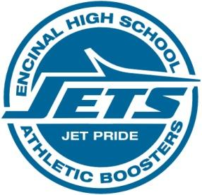

https://drive.google.com/file/d/1hN9EqWJORR2KzCNg62xzp8fWACkYvA8m/view?usp=sharing

Next Month’s meeting: April 15, 2020 at _Pier 29_

