Encinal High School  Athletic Boosters – Board Meeting  Agenda  February 19, 2020 6:30pm - EHS Room 605 | 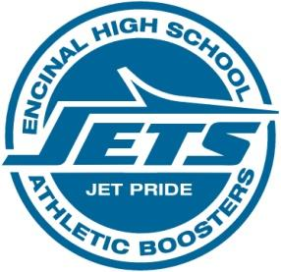

- Welcome
  - Approve Minutes from previous meeting

Athletic Director’s Report -Lani/Kevin
  - .

Treasurer’s Report - Vince

  - No update on 503 status, I did just pay the general liability through non profits insurance, they are aware of our status and reinstatement. We will need to add Grad night back into the insurance policy when the broker returns on the 19th.
  - Met with ARPD today and paid the final balance for the crab feed $ 3334.00, both same day insurance and ABC license has also been completed.
  - Beginning balance as of 12/31/19 $19,798.51
  - Deposits and Credit $9,603.70
  - Withdrawals and debits(3) $2,831.03
  - Ending Balance as of 01/31/20 $26,571.18
  - The crab feed sheet was updated today with a total of $ 17,750 being sold.

Handbook Update - Yenju

Crab Feed - Helene
  - Planning Updates
  - Vegetarian option
  - Inventory and Transportation
  - Giving Tree
  - Signage - state of signs we have and what we need...
  - Alumnae ad and coach tickets

Adjourn

Next Month’s meeting: March 4, 2020 at O Club- CF Walk Through

